MINISTRY OF EDUCATION AND SCIENCE REPUBLIC OF KAZAKHSTAN
SCIENCE COMMITTEE
CH. VALIKHANOV INSTITUTE OF HISTORY AND ETHNOLOGY

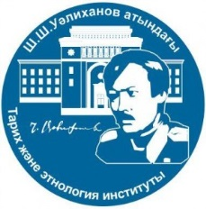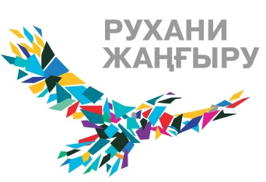

PRESS-RELEASE

The Council of Young Scientists of the Institute of History and Ethnology named after Ch. Ch. Valikhanov on May 25, 2021 at 11.00 h. holds an international scientific and practical conference "Actual problems of the agrarian history of Kazakhstan in the Soviet period: power and society".
Despite the sufficient amount of research on the agricultural issue in domestic and foreign historiography, today there is an active rethinking of the history of agriculture and the peasantry in Kazakhstan during the Soviet period from the standpoint of new methodological approaches and concepts. The Soviet period in the history of Kazakhstan radically influenced the development of agriculture. Kazakhstan, in addition to the supplier of heavy industry products, was a significant region in the all-Union production of agriculture. However, this industry has accumulated a lot of problems that hinder its development. One of the reasons for the plight of agriculture was the undivided power of the administrative system over the peasant. In an effort to unify agricultural production, the central government took little account of the interests of the republic in the division and comprehensive development of labor, regional potentials and needs. Under the conditions of the unified national economic complex of the country, the dependence of the republic on the center increased. The conference is held within the framework of the project AP08052897 "The peasantry of Kazakhstan in the post-war decade: social transformation and everyday life".
The purpose of the conference is to determine the actual problems of studying the agrarian history of Kazakhstan in the Soviet period in the context of interaction between the government and society in the process of socio-economic transformation of the traditional structure of Kazakh society.
Main directions of the conference:
- Features of theoretical and methodological approaches in the study of the Soviet agrarian history of Kazakhstan;
- Actual problems of domestic and foreign historiography on the agrarian history of Kazakhstan in the Soviet period;
- Types of sources and problems of source studies on the history of the Soviet peasantry in Kazakhstan;
- New economic policy and the famine of 1921-1922 in Kazakhstan;
- Forced collectivization and peasant demonstrations;
- The famine of 1931-1933 and the fate of the Kazakh nomads;
- The peasantry and the repressions of the 1920s and 1950s in Kazakhstan;
- the specifics of the study of the post-war peasantry, the peculiarities of peasant everyday life;
- The problem of studying the development of virgin land in Kazakhstan;
- Coverage of the agricultural issue in textbooks on the history of Kazakhstan.
Working languages of the conference: Kazakh, Russian, and English.
Conference starts: May 25, 2021, 11: 00 a.m.
Format: Zoom-based conference (ID: 883 0295 2903, password: 518489)
Contacts of the organizing committee: 050010, Almaty, Shevchenko Street, 28, Ch. Ch. Valikhanov Institute of History and Ethnology MES RK, scientific secretary – Kozybayeva M.M. (8777-367-80-83), junior researchers Bekenova Almagul (8705-775-23-93), Zakarya Rakhmetolla (8701-795-17-82).

Sincerely, the organizing committee

